UArctic Student Website
Request for Tender (RFT)
17/06/2013

Conditions of Call
The University of the Arctic is seeking offers for the development of its student web portal, according to the conditions and specifications outlined in this document.
- Call is open to all members of the University of the Arctic, as well as their current IT/web service providers.
- Deadline to submit offers is June 30, 2013 with candidate(s) chosen by July 31, 2013.
- Submission of final work to be completed by Dec 31, 2013.
- Offers shall be in the form of an initial estimate, with final specification for the project and agreement made following consultation with the chosen candidate.
- Offers shall include:
  - Estimated schedule and work plan for each project component
  - Estimated work hours for each project component
  - Hourly rate for each project component
  - Information on the company/institution, previous similar experience, and links to similar work
  - Explanation of proposed solutions to meet requirements, as specified in this document
  - Technical summary of the web solution, including proposed hosting, content management system, and other solutions
  - Summary of follow-up questions and requests for further information that would be needed to develop final project specification and project agreement
  - Contact person for project management.

Required Work
- Graphic and web design of UArctic student website, according to UArctic Graphic Guidelines and this RFT. Final design approved by UArctic prior to implementation.
- Implementation and hosting of UArctic student website using CMS system (chosen in consultation with UArctic), including all required templates, administrative tools, and supporting database structures, and other elements defined in the RFT and the approved design.
- 60 hours follow-up support following submission of work, to address needed adjustments and corrections
- Ongoing hosting of UArctic student (and primary) websites. Further development and maintenance costs beyond the terms of the tender are to be invoiced separately.
- The design of the primary UArctic website will be developed under a separate agreement, following-on from the design of the student portal.

Web and Interaction Design Principles
- Bigger, brighter visually
- Own identity, but within UArctic graphic brand
- Follow model of network and destination student marketing sites (“Study In…”)
- Bright photos with northern faces & places
- Clear navigation clues
- Support for mobile phones and small screens
- Catalogue interface improvements - Catalogue at centre of student portal functionality
- Simple interactivity up front, more advanced search features open if needed

Benchmark & Other Example Models
- Kilroy Education (http://education.kilroy.eu/) (benchmark)
- StudyPortals.eu (http://www.studyportals.eu/)
- StudyInHolland (http://www.studyinholland.nl/)
- StudyInNorway (http://www.studyinnorway.no/)
- StudyAdelaide (http://studyadelaide.com/)

Audience
- Narrow focus to “northern-relevant” studies
- Current Students
  - Mobility seekers
- Prospective/Future Students
  - Full Degree
  - Shorter programs/diplomas
  - Professional/in-career
- Qualifications/upgrades
- Seeking shorter summer/field courses
- Outside and inside the North

Administration
- Open source CMS, if possible
- Distributed user access from different locations and institutional environments (Admin access from anywhere, multiple admins and content creators, ie, cannot be limited to single institutional/enterprise framework)
- Own Template Creation/Modification
- Flexible creation of sets for different data types
- Tech Support (not 24/7, but within 1-2 days)
- Domain administration and ability to set custom URLs (e.g. www.uarctic.org/north2north)

Supporting Data Sets
- Focus on re-use of data sets for different purposes and audiences
- Ability to also pull in information from external sources, using open APIs, etc.
- Information synergies, without too much parallel work
- Data sets summarized and related fields summarized in Appendix II.

Proposed Information Structures and Required Elements

UArctic Introduction
- What is UArctic?
- How to study/access UArctic programs
  - Enrolled in member institutions
  - Not enrolled, etc.
- FAQ
- Country Profiles (links to StudyinFinland, StudyinNorway, etc.)

UArctic Academic Programs
- Circumpolar Studies (BCS)
- north2north
- Graduate Studies
  - General info
- Links to Field School
- Links to Endorsed programs

UArctic Catalogue
- Programs
- Courses
- Field Schools (includes non-UArctic)
- Graduate Programs
  - Permafrost (Includes non-UArctic)

Map Viewer/Tool/Interface
- UArctic members (campus map) – member profile
- Theme-based maps (indigenous peoples, sea ice, biology, etc.), using custom-defined map layers (KML, etc.)
- Catalogue-linked courses and programs
- Map viewer should support circumpolar projection

Member Profiles
- Description
- Fields of Study/Specialties, Focus areas
- Map/Campus Locations
- Logo, photo images, campus, visuals, videos
- Link to offered programs/courses in Catalogue, Theme Pages
- Contact Information (linked to member profiles)
- Recent news

Theme Pages
- Theme/subject overview text
- Links to relevant Thematic Networks
- Links to relevant programs/courses in Catalogue
- Links to institutions with that speciality/focus
- Links to relevant news
- Themes, based on keyword tags: People & Culture, Environment, Governance, Business & Industry, Climate Change
News Feeds
- Ability to tag/categorize different ‘news channels’, each with its own RSS feed
- Program/course announcements & application calls
- General Arctic News, theme/subject related
- Study and funding opportunities: PhD/post-doc positions, awards, stipends, mobility opportunities
- Events: Seminars, Conferences, Workshops (including Events Calendar feed: iCal)

Student Experiences
- Student success
  - Alumni, Legacy, where are they now?
- Text stories, photos, multimedia
- Student Work
  - Posters, Paper publications, presentations, etc.
- Linked to the Search Term/Results/Keywords

Social Media
- Extent of SoMe integration still to be defined in final specification, but could include:
  - Facebook
  - Twitter (from news feeds)
  - LinkedIn (linked to contact database)

Optional or Future Elements

Student Association and Alumni
- Links to these resources, where they exist
- Jobs, Career planning
- Mobility Programs & Internships

Learning Resources

Require ability to flexibly integrate data and web services from other providers (via APIs or other solutions) into the UArctic website, including:

Arctic VLT/Online Learning Environment(s)

MOOC

Metadata

Library and Document Server

Atlas: Maps & Graphics

Learning Aids

Photo Library

Distributed Content to other Websites
- Catalogue/UArctic Module/Object
- Modules pushed to member websites, other partners

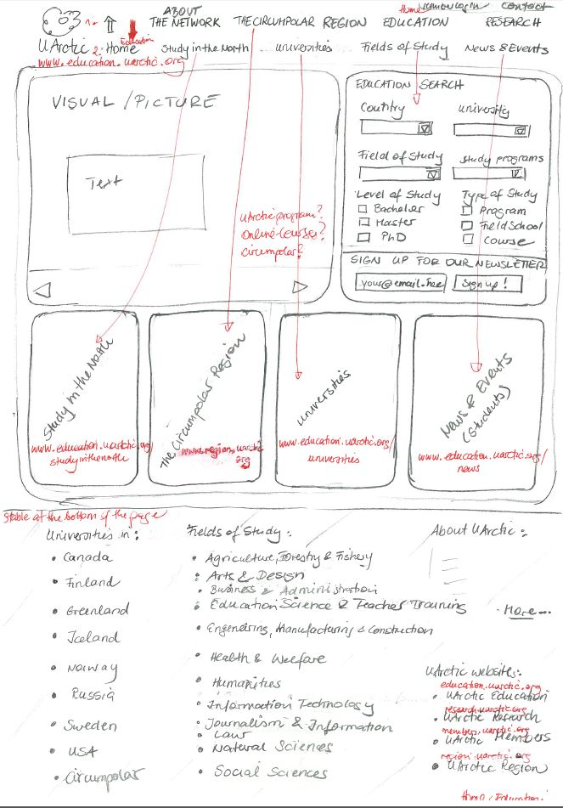
Appendix I: Example Landing Page Mockup

Appendix II: Summary of Planned Data Sets
1 Member Information
1.1 OrgID
1.2 Organization Name
1.3 Country
1.3.1 Defined Set
1.4 Category of Membership
1.4.1 Full
1.4.2 Associate
1.5 Logo (image file)
1.6 Type of Institution
1.6.1 Higher Education
1.6.2 Other Organization
1.7 Thematic Networks
1.8 north2north
1.8.1 yes/no
1.9 Fields of Study
1.9.1 Defined by ISCED97
1.10 Campus Locations
1.11 Website
1.12 Thematic Areas / Strategic Focus
1.13 Circumpolar Studies
1.13.1 yes/no
1.14 Profile / Description of Institution
2 Catalogue
2.1 Programs
2.1.1 CDM.UArctic
Organization name
Program name
Program country
Program level
Program registration deadline (dd.mm.yyyy)
Program field of study
Program language
Program description
Program objectives/outcomes
Program weblink
Program search words = keywords
2.2 Courses
2.2.1 CDM.UArctic
Organization name
Course name
Course code
Course country
Course level
Course form of teaching
Course date begin (dd.mm.yyyy)
Course date end (dd.mm.yyyy)
Course registration deadline (dd.mm.yyyy)
Course field of study
Course language
Course formal prerequisites
Course description
Course admission description
Course teaching place
Course ECTS credits
Course teaching term
Course objectives/outcomes
Course recommended prerequisites
Course weblink
Course form of assessment
Course search words = keywords
3 Thematic Networks
3.1 Arctic Coastal and Marine Issues
3.2 Arctic Engineering and Science
3.3 Arctic Extractive Industries
3.4 Arctic Geology
3.5 Arctic Law
3.6 Arctic Sustainable Arts & Design
3.7 Communicating Arctic Research
3.8 Digital and Media Arts
3.9 Distance Education and e-Learning
3.10 Energy in New Time
3.11 Environmental Impact Assessment of Industry Contaminated Areas
3.12 Environmental Training and Education for Sustainable Development of the Arctic (NETESDA)
3.13 Geopolitics and Security
3.14 Global Change
3.15 Health and Well-being in the Arctic
3.16 Indigenous Arts and Crafts
3.17 Local and Regional Development in the North
3.18 Managing Small and Medium Sized Enterprises in the North
3.19 Natural Hazards
3.20 Northern Food Security
3.21 Northern Governance
3.22 Northern Tourism
3.23 Permafrost
3.24 Polar Ice, Climate and Land Dynamics (PICD)
3.25 Social Work
3.26 The Verdde Program
3.27 World Images of Indigenous People of the North
4 Contact Information (People)
4.1 OrgID
4.2 First Name
4.3 Last Name
4.4 Title (Institution)
4.5 Title (UArctic)
4.6 E-mail
4.7 Affiliations
4.7.1 Governance and Management
Board of Governors
Board Finance Policy Committee
Council
Friends
Pomot
Ma-Mawi (Senior Management Group)
4.7.2 Administrative Support Services
UArctic President & International Secretariat
UArctic International Academic Office
UArctic Finance Office
UArctic Research Office
UArctic Russian Information Centre
UArctic Rectors’ Forum Planning Committee
4.7.3 Program Coordination (Offices)
UArctic Field School Office
UArctic north2north International Coordination Office
UArctic Undergraduate Office (BCS)
UArctic Thematic Networks Office
UArctic GoNorth Office
UArctic Graduate Studies Office
4.7.4 Council Standing (Council) Committees
Academic Quality Committee
Toyon (Executive Committee)
Indigenous Issues Committee
Membership and Nominations Committee
Ofelas
4.7.5 Program Teams
Undergraduate Area
GoNorth
Mobility
Research Leadership Team (Mimir)
Thematic Networks
Individual Thematic Networks Affiliations (List)
Graduate Area
4.7.6 Affiliation within Institution
Head of Institution
Alternate on UArctic Council
Representative on Council of UArctic
Administrative contact for head of institution
Academic office (Registrar)
Head of Information Office
Head of International Relations
Head of Computer Services/ICT
Webmaster
Library contact person
north2north Academic contact
north2north Administrative contact
Site coordinator of the Circumpolar Studies program
4.7.7 Relation to UArctic
Communications contact person for UArctic
Contact person for UArctic registration concerns
Contact person for financial matters (membership fee)
4.7.8 Contact person for UArctic related programmes and activities in institution
Rectors’ Forum representative
Rectors' Forum administrative contact
UArctic Field School responsible
GoNorth program coordinator
Catalogue responsible
4.8 Phone Number
4.9 Contact Picture / Profile Image
5 Geodata
5.1 Campus Locations
5.1.1 Latitude
5.1.2 Longitude
5.1.3 Address
5.2 Thematic Maps
5.2.1 KML
6 Themes
6.1 People & Culture
6.1.1 Keywords
6.1.2 Thematic Networks
6.1.3 Thematic Maps
6.2 Environment
6.2.1 Keywords
6.2.2 Thematic Networks
6.2.3 Thematic Maps
6.3 Governance
6.3.1 Keywords
6.3.2 Thematic Networks
6.3.3 Thematic Maps
6.4 Business & Industry
6.4.1 Keywords
6.4.2 Thematic Networks
6.4.3 Thematic Maps
6.5 Climate Change
6.5.1 Keywords
6.5.2 Thematic Networks
6.5.3 Thematic Maps

