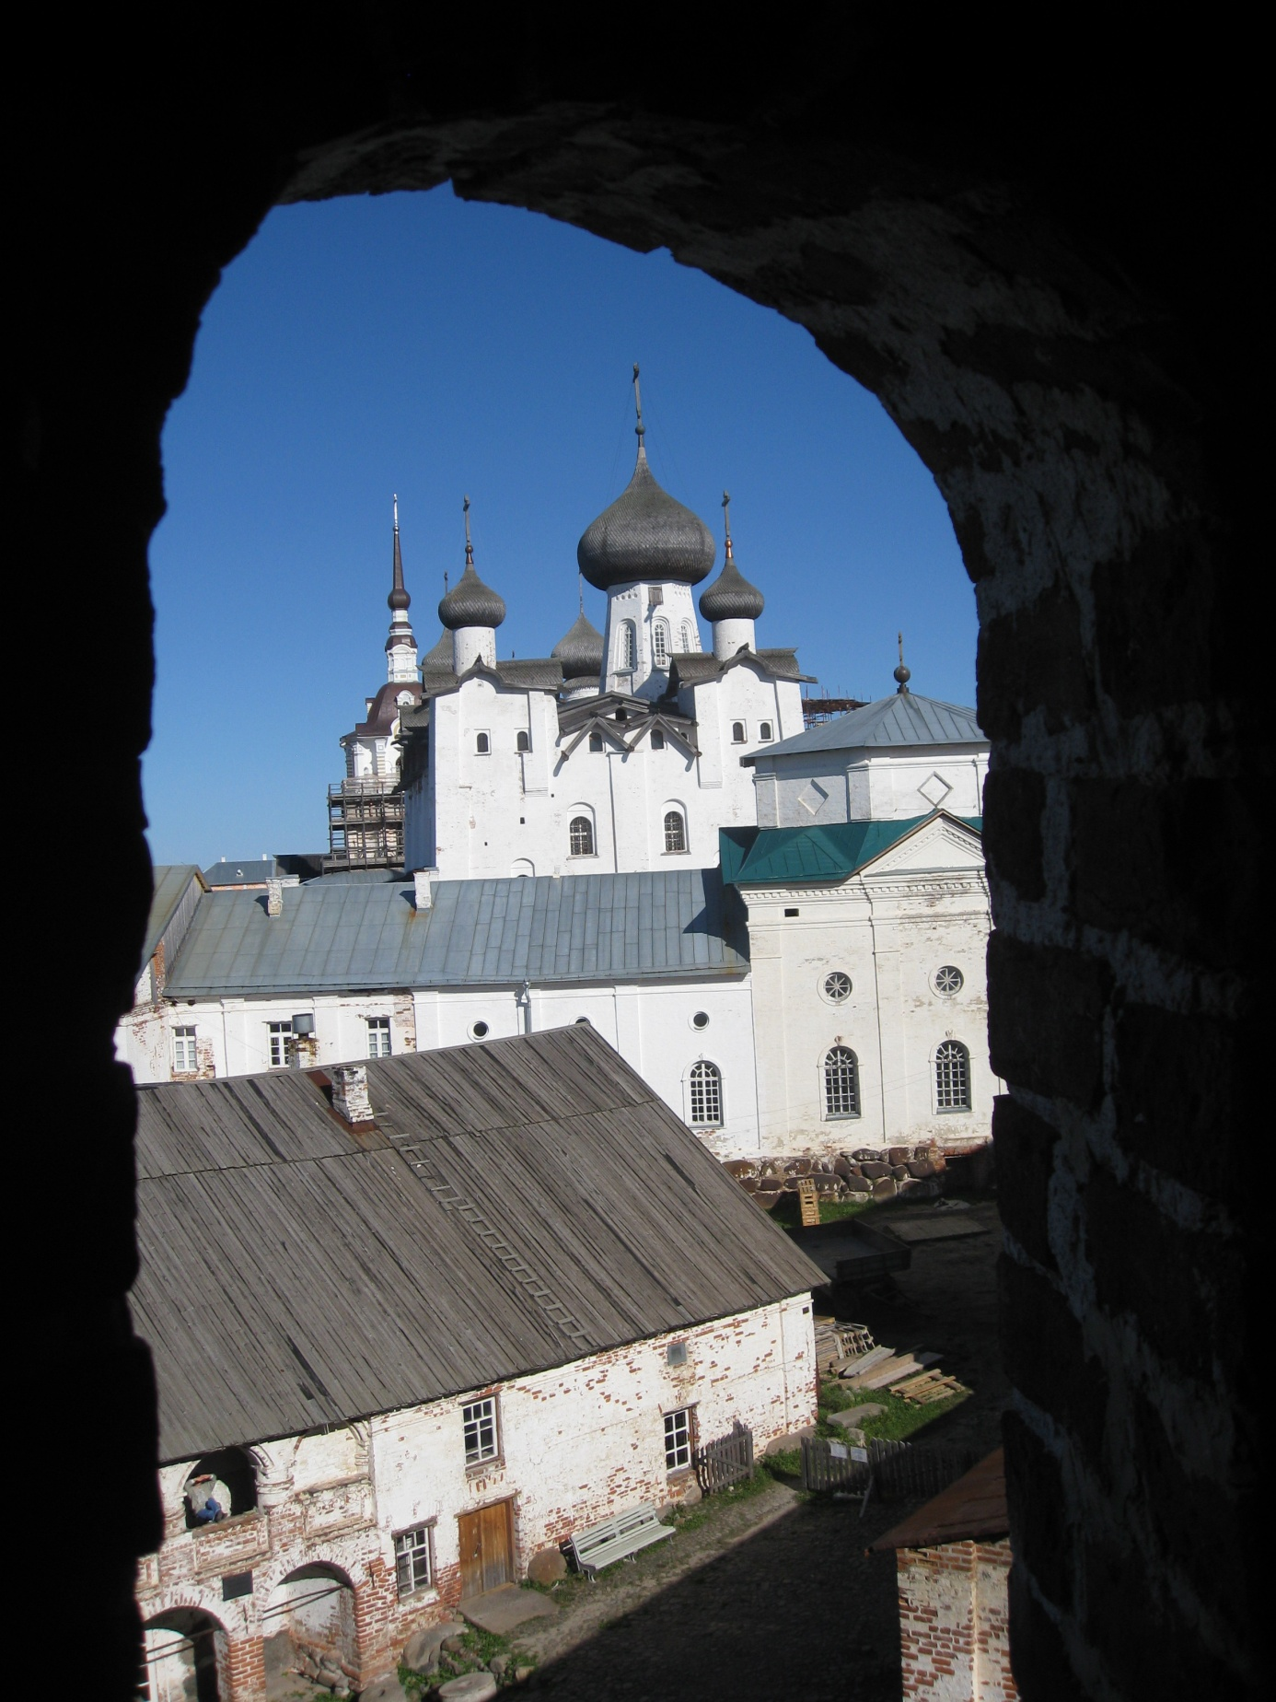

Living in the North

A seminar on peoples, cultures and living conditions in the Barents region

Barents Secretariat , Rådshusgata 8, Kirkenes

Finnmark University College and Barents Institute, University of Tromsø

Friday, September 30 at 12.15.
Ends at Saturday, October 01 at 13.00

Finnmark University College and Murmansk State Humanities University have initiated a project on developing knowledge and insight on peoples and cultures living in the north. The first results of this cooperation project will be presented at an open seminar in Kirkenes.

More on the project:
Finnmark University College has initiated a project with Murmansk State Humanities University, funded by the Barents Secretariat, on developing knowledge and insight into living conditions in the high North, with a special emphasis on peoples, cultures, political and economic development. Other Russian universities have also been invited to take part in this project as Murmansk State Technical University. The project goal is to develop knowledge on life in the High North that can be used for teaching purposes in a joint bachelor programme: Bachelor of Northern Studies.

The first contributions of this project will be presented during “Forskningsdagene” in Kirkenes at the Barents Secretariat. Most of the presentations will be on cultural aspects in our part of the Barents region, especially at Kola, but some presentations will also be focusing on cross-border cooperation, politics, industrial life and economic development.

Program details:

Friday, September 28.

12.30 Welcome.
Rector Sveinung Eikeland, Finnmark University College.

12.40 Project presentation – building knowledge on the Barents region
Project lead, Bjorn K. Sagdahl

12.50 Welcome speech and presentation on Regional Development by
administrative manager Svein Helge Orheim, Barents Institute.

13.10 The Barents Region Cooperation,
Rune Rafaelsen, Director, Norwegian Barents Secretariat

13.30 Regional Development out of a High North Perspective
Rector Sveinung Eikeland

13.50 Social Cultural Space of the Kola North
Olga Ivanishcheva, Dean, MSHU

14. 10 Questions and discussion
Coffee break

14. 30 Culture of the Kola North
Assoc. Prof. Tatiana Korotkova, MSHU

14.50 Cross-Cultural Awareness in the Epoch of Globalisation
Assoc. Prof. Tatiana Lisitsyna, MSHU

15.10 Man and the North in the Russian, American and Norwegian Literature
Marina Naumliuk, MSHU

15.30 Question and discussion

16.00 Summing up

19.00 Dinner for speakers, hosted by the Barents Institute

Saturday Oct 1.

10.00 Rethinking the East- Sami People: The Relationship between Nature and Culture
Peter Haugseth, Finnmark University College

10.20 Impacts of Geographic and Climate Conditions on Northern Mentality
Assoc. Prof. Tamara Tuchkova, MSHU

10.40 The Notion of the Labour Market in the North
Tatiana Belevskih, MSHU

11.00 Coffee break

11.30 The Kola Economy and Development
Alexander Shilovskiy, MSTU

11.50 Regional Issues of International Relationships in the Barents Region
Assoc. Prof. Marina Lukina, MSHU

12.10 Questions and discussion

12.50 Summing up

19.00 Dinner for speakers, hosted by Finnmark University College

