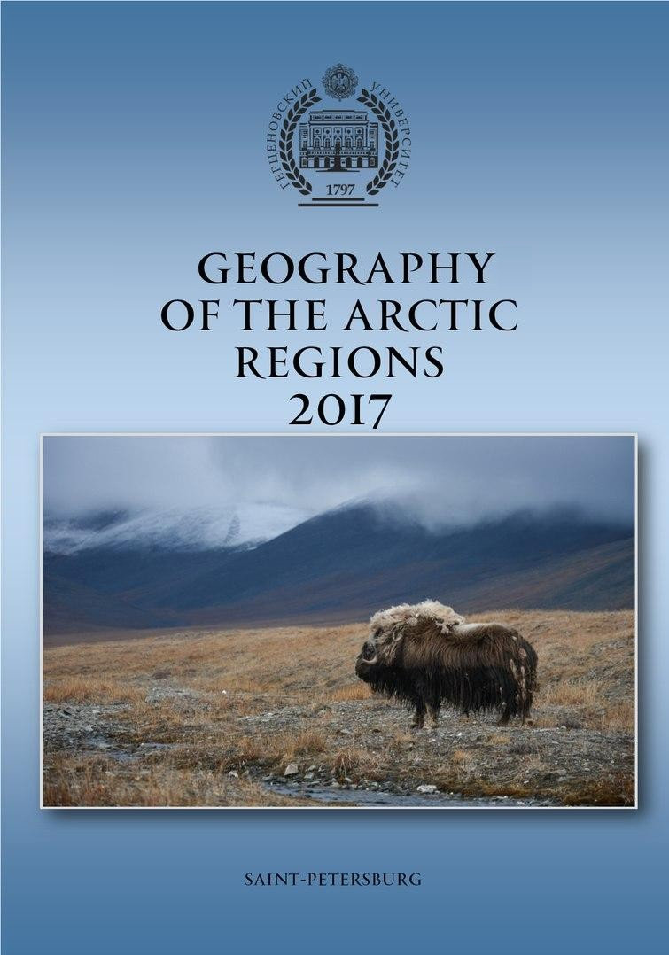
2ц2

The First International Scientific and Practical Conference "Geography of the Arctic Regions"
Herzen State Pedagogical University of Russia
Northern Water Problems Institute of the Karelian Research Centre of Russian Academy of Sciences
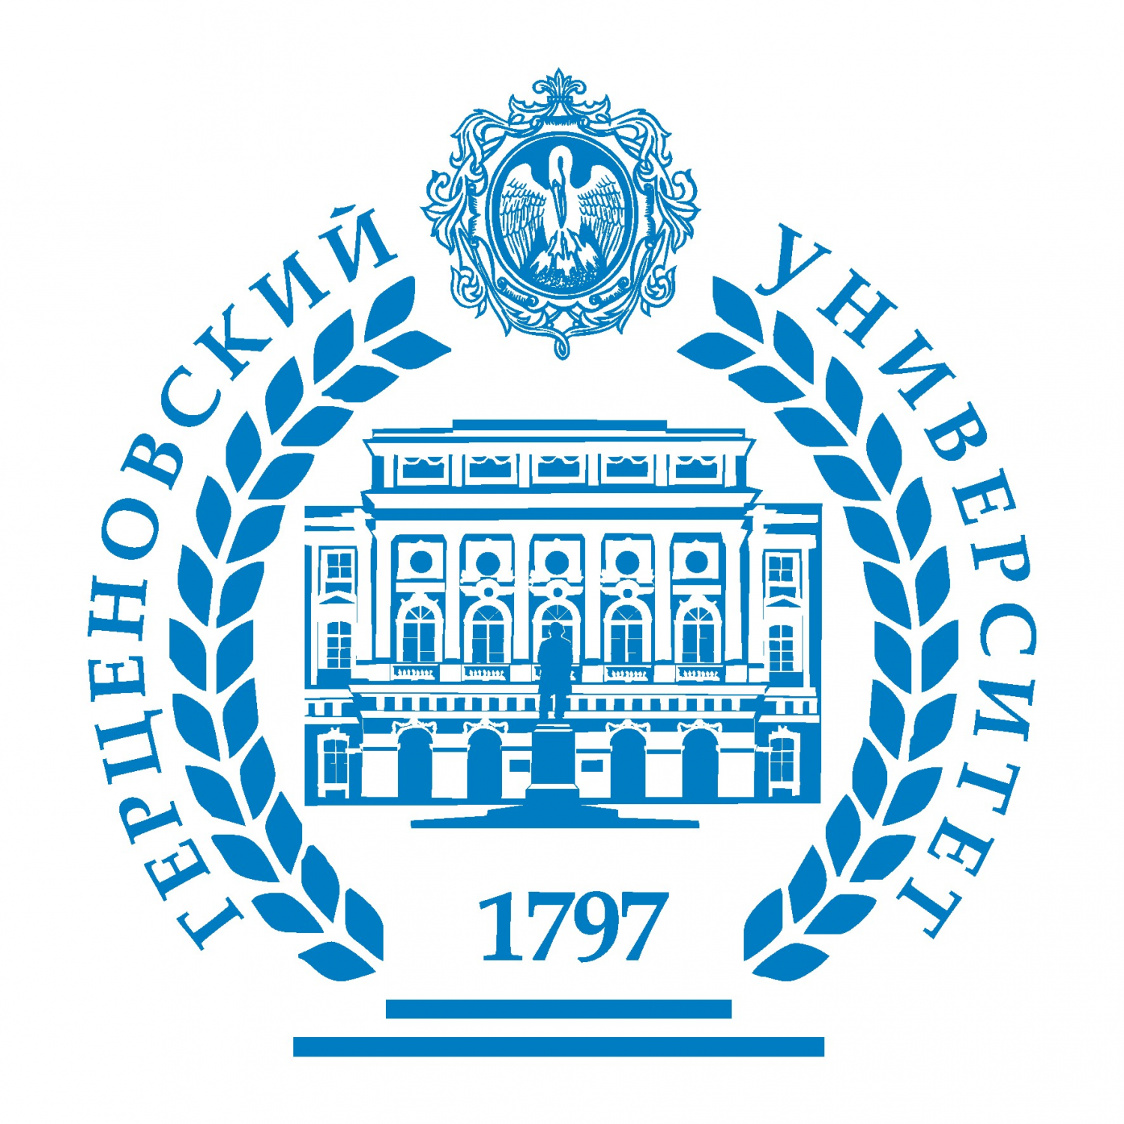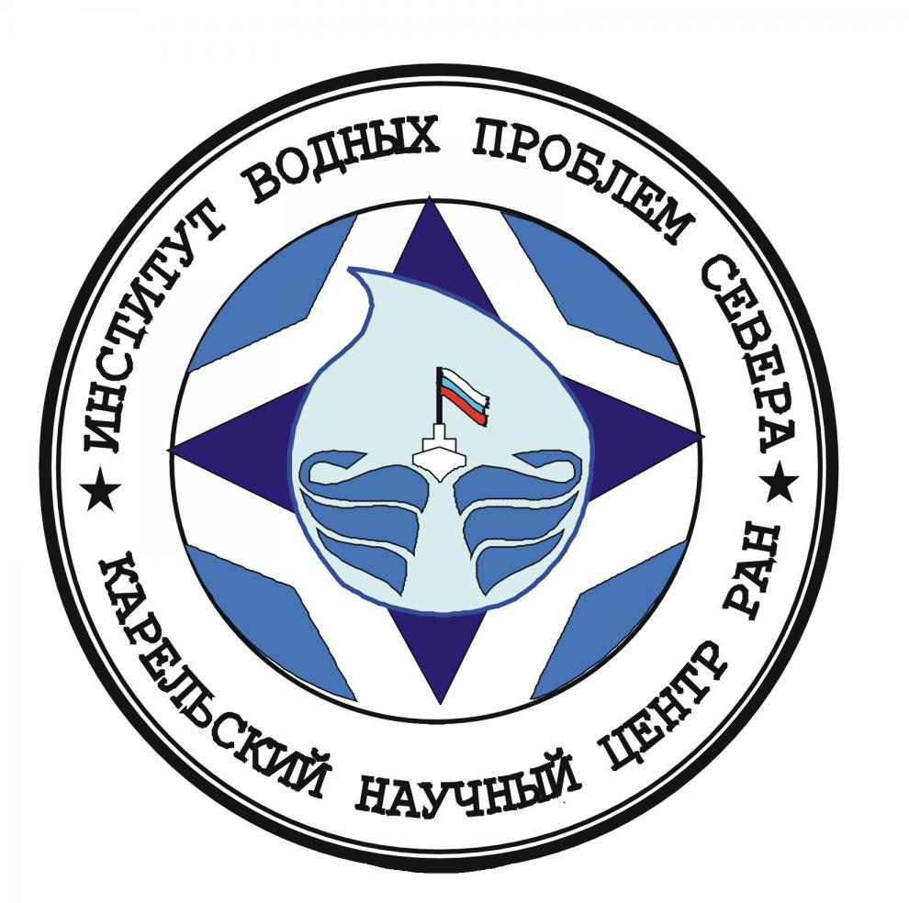University of the Arctic (UArctic)

Organizing Committee of the Conference Chairperson:
Doctor of geographical sciences, prof. D.A. Subetto, director of the Northern Water Problems Institute of the Karelian Research Centre of Russian Academy of Sciences, Head Department of Physical Geography and Nature Management of the Herzen State Pedagogical University.

Co-Chairs:
Academician of the Russian Academy of Education Doctor of pedagogical sciences, prof. V.V. Laptev. The first pro-rector of the Herzen State Pedagogical University of Russia;
Ph.D., prof. S.I. Makhov, acting pro-rector on educational work of the Herzen State Pedagogical University;
Corresponding member RAO, doctor of geographical sciences, prof. Yu.N. Gladkiy, head Department of Economic Geography the Herzen State Pedagogical University;
Ph.D., docent V.G. Mosin, Dean of the Faculty of Geography of the of the Herzen State Pedagogical University;
Academician of the Russian Academy of Sciences, Doctor of geographical sciences, prof. V.A. Rumyantsev, Russian Academy of Sciences, Institute of Limnology;
Members of the Organizing Committee:
Ph.D. docent D.A. Gdalin, deputy Dean of the Faculty of Geography the Herzen State Pedagogical University;
Ph.D., docent V.F. Kulikov, Department of Physical Geography and Nature Management the Herzen State Pedagogical University;
Doctor of biological sciences, prof. N.V. Lovelius, Department of Physical Geography and Nature Management the Herzen State Pedagogical University;
Doctor of geographical sciences, prof. M.A. Naumenko, head of the department Laboratory of Hydrology of the Institute of Limnology of the Russian Academy of Sciences;
Doctor of pedagogical sciences, prof. E. M. Nesterov, head of the department of Geology and Geoecology, Herzen State Pedagogical University;
Doctor of geographical sciences, prof. L.A. Pestryakova, North-Eastern Federal University.M.K.Ammosov;
Doctor of geographical sciences, prof. D.V. Sevastyanov, head of the department of regional studies and international tourism of St. Petersburg State University;
Doctor of geographical sciences, prof. V.D. Sukhorukov, head of the department of Methods of teaching Geography and Local History Studies.
Secretariat:
Ph.D., Assis. Yu.A. Kublitsky, Department of Physical Geography and Nature Management;
Assis. I.M. Grekov, Department of Physical Geography and Nature Management;
Assis. P.A. Leontiev, Department of Physical Geography and Nature Management;
MSc L.S. Syrykh, REC "Ecology and Rational Nature Management";
Engineer-laboratory assistant V.V. Brylkin, Department of Physical Geography and Nature Management;
Ph.D, docent A.N. Paranina, Department of Physical Geography and Nature Management the Herzen State Pedagogical University;
Assis. N.V. Sokolova, Department of Physical Geography and Nature Management;
Ph.D student O.A. Gildeeva, Department of Physical Geography and Nature Management

Dear colleagues!
We invite you to take part in the international scientific-practical conference "The Geography of the Arctic Regions"

THE OBJECTIVES OF THE CONFERENCE:
- To bring together scientists interested in the geography of the Arctic regions
- To discuss the problems of the Arctic regions, related to their geographical location
- To find new possibilities of cooperation
- To develop interdisciplinary approaches for problem-solving in the Arctic regions
The conference will be held in Saint-Petersburg, Russia, at the Herzen State Pedagogical University of Russia at 9-10 November 2017.
The forth coming Conference is planned to discuss the results of the research in the following areas:

- Evolution of the natural environment of the Arctic regions in the late Pleistocene and Holocene
- Current state of the circumpolar regions. Problems of the rational nature management and environmental protection in the Arctic.
- Studying and preserving natural and cultural heritage of the Arctic. According to the geo- archeological studies.
- GIS-technology, modeling and modern methods of geographical research
- Socio-economic development of the Arctic sector. Tourism.
- Interdisciplinary research in the Arctic regions.

The Conference will be held in the form of plenary and sectional sessions. At the conference will be organized "School of young scientists", for bachelors, masters, postgraduates students and young scientists (under 35 years). The details are in the end of the information letter.
As a results of the conference, the pdf-files will be placed in RISC. A hard copy of the book of abstracts will be send on request and with an addition charge; price will be announced later following the deadline according to the amount of the applications.
For the participation in the conference it is necessary to send the application form and the text of the report (article) before October 20th, 2017. File names should begin with the first author's last name, the extension .docx or .doc (Ivanov_abstract.docx; Ivanov_application.docx). The application template is attached.

Organizing committee address:
191186, St. Petersburg, Embankment of the Moika River, 48, Herzen State Pedagogical University of Russia, building. 12, Faculty of Geography. E-mail: HerzenArctic@yandex.ru
The Organizing Committee reserves the right to reject reports and articles that do not correspond to the theme and directions of the conference or are issued in violation of the requirements.
The registration fee for participation in the conference is 500 rubles (10$), for young scientists under 35 (students, graduate students) - 300 rubles (6$). Registration fee can be paid during the registration of participants at the conference on 09.11.2017. At the address: St. Petersburg, Embankment of the Moika River, 48, Herzen State Pedagogical University of Russia, corp. 4, the Blue Hall of the Student Club. For the distance participation and its methods of payment please contact the Organizing Committee E-mail: HerzenArctic@yandex.ru.

The registration fee does not include the accommodation and the meals during the conference. About any questions according to the accommodation and the official invitation please contact the Organizing Committee E-mail: HerzenArctic@yandex.ru.

Example of the abstract format

Content up to 3 pages. Page format - A4. Font - Times New Roman (without styles), size 12p; Margins on A4 paper are 2 cm from each side. Line spacing is single. Paragraph - 1 cm. 1st line - title in capital letters; 2nd line - the initials and surnames of the authors; the third line - the name of the organization, the city, country and the author's email address in capital letters 12 pt., the location is on the right.
Leave a blank line between the affiliations and the abstract body.
Abstract. 2-3 sentences on the subject of the article. Align to the width of the page.
Key words. Not more than 5.
Leave a blank line between key words and text body.
Text of article. Align to the width of the page. Illustrations (resolution not less than 300 dpi.) in the text. References to the literature in square brackets according to the format [Ivanov, 2000]. Alphabetical list of the literature. Not more than 5,
Text pages are not numbered.
Materials are published in the author's edition.
Articles are accepted in Russian and English languages.

ESTIMATION OF THE EROSION HAZARD OF THE RELIEF
Ivanov I.I.¹, Petrov V.V.² 1Herzen State Pedagogical University, St-Petersburg, ivanov@mail.ru 2Moskow State University of M.V. Lomonosov, petrov@mail.ru

Abstract: The north-west part of the East-European Plain is considered traditionally as the zone without gullies. Nevertheless, under certain natural conditions the human intervention may cause the development of gully erosion here. The gully situated in the valley of the Ifenka River on the south of Leningradskaya region is described as an example.
Key words: gully erosion, East-European Plain

Gully erosion is actively developing in the conditions of the forest-steppe and steppe zones (fig. 1.) [Timofeev and Bylinskaya, 1997]...

References:
Timofeev D.A., Bylinskaya L.N. Map of the assessment of the erosion hazard of the of the Russian terrain// Regularities in the manifestation of erosion and channel processes in various natural conditions (abstracts of the IV Scientific Conference). Moscow: Izd-vo MGU, 1997, pp. 24-25.

REGISTRATION FORM
Full name
Institution
Title (e.g. Dr., Prof. etc.) / Position
Postal address (with a postcode)
Phone
e-mail:
Topic of section:
Title of report:
Form of participation: distance or in-person.
Type of in-person participation:
- only publication of the abstract
- oral presentation and publication
Do you need a printed digest of the abstracts for an extra fee? Yes/no
Student, Master / Ph.D student, Young researcher (only for "the School of Young Scientists")
Do you need a participant certificate? Yes/no
Do you need an official invitation? Yes/no
Do you need a visa support letter?

The conference will be in the form of plenary and sectional meetings. The conference will host "the School of Young Scientists", for bachelors, masters, Ph.D and young scientists (under 35). On the title page of the presentation, participants under 35 years old should put a logo that matches their education level. The images are shown below or can be downloaded from the link https://yadi.sk/d/tEW6ehEb3MtDej. The certificates will be issued.

Бакалавры Магистры Аспирант

Bachelor Master Ph.D student

WE WOULD BE GRATEFUL IF YOU COULD SHARE THE INFORMATION ABOUT THE CONFERENCE AMONG YOUR COLLEAGUES!

