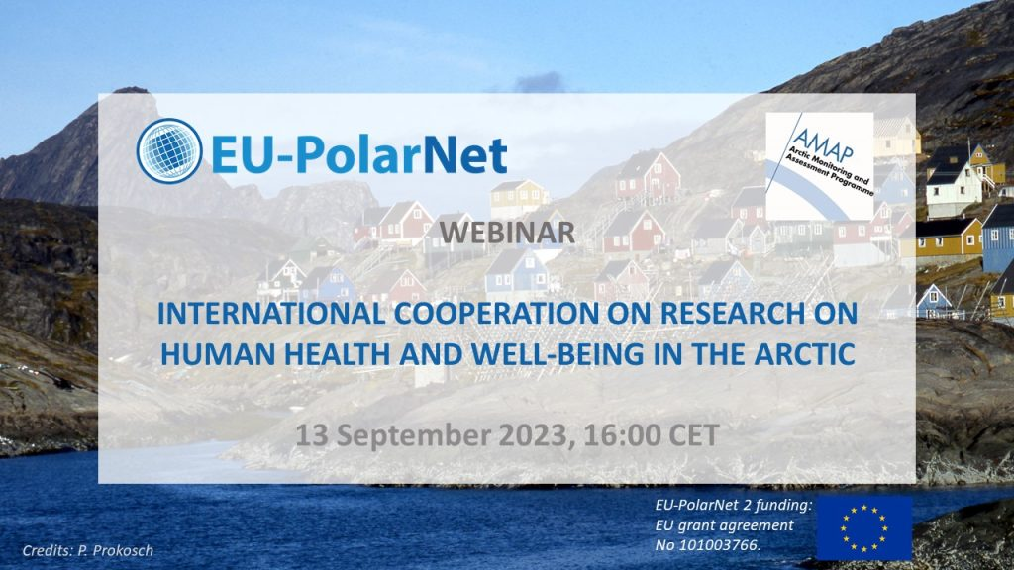
Webinar: INTERNATIONAL COOPERATION ON RESEARCH ON HUMAN HEALTH AND WELL-BEING IN THE ARCTIC
People living in the Arctic, especially Indigenous people, are experiencing increasing challenges to their health and well-being owing to the impacts of climate change on their environment, affecting the species they hunt, fish or harvest and thus their food security, among others. To better understand these complex challenges, their impacts and potential means to address them, a broad One Health type of approach is needed, encompassing the health of ecosystems, animals and humans. Such an approach must also bring in the traditional, long-term knowledge of the Indigenous Peoples who inhabit the Arctic and see it from a holistic, all-encompassing perspective. In addition to climate-related health risks, the northward transport of chemical contaminants from mid-latitudes via air and oceanic currents affects Arctic species of plants and animals as well as humans; identifying “new” chemicals in the Arctic represents an international challenge. These issues will be presented based on current international research activities conducted under the EU, AMAP and their respective member countries.
Speakers:
- Cheryl Khoury, Health Canada, Co-lead AMAP Human Health Assessment Group
- Arja Rautio, Thule Institute, University of Oulu, Finland
- Tiff-Annie Kenny, University of Laval, Quebec
- Katrin Vorkamp, Aarhus University, Department of Environmental Science, Roskilde, Denmark
The webinar will be recorded. You can watch the webinar again later on our YouTube channel.
- Location: Online
- Date: 13 September 2023
- Time: 16:00 (CEST)
Register here for the webinar
Information on the speakers and their presentations:
Cheryl Khoury, Health Canada, Co-lead AMAP Human Health Assessment Group
‘International cooperation on human health issues in the Arctic: The work of the Human Health Assessment Group’
Abstract: The Human Health Assessment Group (HHAG) expert group of the Arctic Monitoring and Assessment Programme is dedicated to circumpolar research and human biomonitoring of contaminants as well as the synthesis of trends and assessment of human health effects in the Arctic. The HHAG is composed of experts from circumpolar countries, and Permanent Participants. For more than twenty years, it has produced human health assessment reports at regular intervals that are intended to inform policy and decision-makers with respect to international chemicals risk management. The work of the HHAG has highlighted the need to work collaboratively across regions and disciplines to monitor contaminants in the Arctic and identify new and emerging issues. Chemicals management is a complex, long-term, international effort. Collaboration through working groups, such as the HHAG, is critical for this work to be successful.
Arja Rautio, Thule Institute, University of Oulu, Finland
‘One Health as a core principle of health and well-being in the Arctic’
Abstract: The One Health concept recognizes that humans, animals, and ecosystem health are interrelated and interdependent in complex ways. It is an increasingly established concept worldwide as populations face complex challenges associated with global climatic and environmental changes. The Arctic Council has recognized the concept of One Health, and coordination between the various programs and working groups (such as AMAP, CAFF and SDWG), has been improved for achieving an integrated One Health approach. Collaboration is important also with EU-funded projects, such as ArcRisk (https://arcrisk.amap.no/), and INTERACT (https://eu-interact.org) in monitoring of possible contaminants and vectors for zoonotic diseases, and Nunataryuk (Nunataryuk - Home) for modelling and human health risk assessment of anthrax and contaminants from thawing permafrost, as well as the Nordic Centre of Excellence project CLINF (Home - CLINF) for research on climate change effects on zoonotic diseases in the North. The current pandemic arising from the COVID-19 virus represents a classic example of the interdependence of environmental-, wildlife- and human health.
Tiff-Annie Kenny, University of Laval, Quebec
‘Navigating Climate Impacts on Health and Wellbeing in a Changing Arctic’
The many facets of climate change, including rising temperatures, extreme weather events including precipitation extremes, and changes in seasons, can have serious impacts on food security. In the Arctic, where Indigenous communities often rely on subsistence species and country foods, Indigenous Knowledge is needed as a means to better understand the impact of these changes. Currently most research on food security has been based on Western science, but it is important to include Indigenous knowledge because adequate food security is linked to broader factors including harvesting and consumption of country foods, reducing the negative impacts of contaminants and climate change on Indigenous food systems, and addressing the high cost, quality and availability of store-bought food in Indigenous communities. Although the direct effects of climate change on food security and human health are most in focus, the indirect effects may be more serious, given the complexity of the effects of climate change on physical and mental health on both a short-term scale as well as in the medium- to long-term. The health consequences of climate change may be several steps removed from climate, such as an increased prevalence of cardiovascular diseases after climate-stressing events. Climate change is also having an impact on the harvest of fish and other seafood, upon which coastal Indigenous communities are particularly dependent. To understand the impacts of climate change on human health in Indigenous communities, it is important to integrate Indigenous knowledge and frameworks and use holistic approaches to conceptualize climate-health interactions, including climate-contaminant interactions.

Katrin Vorkamp, Aarhus University, Department of Environmental Science, Roskilde, Denmark
‘Human exposure to chemicals of emerging Arctic concern (CEACs)’
Abstract: The accumulation of persistent organic pollutants (POPs) in the Arctic has been documented in collaborative research and monitoring efforts of the last four decades, including the POPs exposure of Arctic populations. Recently, awareness has increased of other problematic compounds than POPs occurring in the Arctic, summarized as chemicals of emerging Arctic concern (CEACs). Combining data from all over the Arctic, their occurrence in the Arctic environment was first summarized and assessed in a report of the Arctic Monitoring and Assessment Programme (AMAP) in 2016. This has raised the question about human exposure to these CEACs, potentially through several pathways. In addition, developments in analytical chemistry have led to an increased focus on the identification of “new” chemicals, applying suspect and non-target screening techniques. International networks such as NORMAN have developed guidelines and arranged interlaboratory trials to strengthen the data basis for quality assurance/quality control (QA/QC) in this rapidly developing field. First research results are emerging from non-target screening projects involving human samples from the Arctic. These techniques will also be developed further in the Horizon Europe Partnership for the Assessment of Risks from Chemicals (PARC) and applied in human biomonitoring and environmental/multisource exposure monitoring in Europe. While research and monitoring will be conducted in both human and environmental monitoring, interlinkages towards a One Health-inspired integration are sought, not least to improve our understanding of human exposure to emerging contaminants. Since similar integrative developments are ongoing in AMAP, these initiatives and networks can learn from each-other and provide mutual inspiration.

